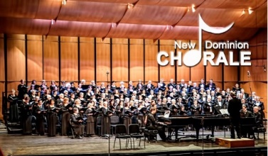

Thomas Beveridge, Artistic Director president@newdominion.org
P.O. Box 6691, McLean, VA 22106-6691 www.newdominion.org
202-244-7191

NEW DOMINION CHORALE TO PRESENT MENDELSSOHN’S ELIJAH

New Dominion Chorale will conclude its 31st season with a performance of Felix Mendelssohn’s dramatic oratorio ELIJAH. The concert will take place on Sunday, May 1, 2022, at 4:00 p.m. at the Rachel M. Schlesinger Concert Hall and Arts Center on the campus of Northern Virginia Community College, 4915 East Campus Drive, Alexandria, Virginia.

The performance, conducted by the Chorale’s Artistic Director, Thomas Beveridge, will feature a full symphony orchestra. Baritone Timothy LeFebvre will portray the prophet Elijah, a role for which he is well known throughout the United States. Other soloists will be soprano Mandy Brown, mezzo soprano Heather Johnson, and tenor Benjamin Warschawski. Also featured will be an octet of solo singers from the choir of Saint Catherine of Siena Catholic Church, Jerry Kavinski, Director.

New Dominion Chorale has distinguished itself amid the crowded choral music scene in the Washington area. It operates as a “singers’ cooperative” without paid management and is one of the area’s largest choral societies, with 185 members. Although there are no auditions to join the Chorale, it has been praised in The Washington Post as “opulent, precise and powerful.” New Dominion Chorale has performed much of the standard repertoire for chorus and orchestra and has also ventured into lesser-known repertoire by Franz Liszt, Robert Schumann and Thomas Beveridge, including his massive “Symphony of Peace.” In addition to its regular performances at Saint Luke Catholic Church and the Rachel M. Schlesinger Concert Hall and Arts Center, the Chorale has also appeared at Washington National Cathedral, The Washington Hebrew Congregation and the Concert Hall of the John F. Kennedy Center for the Performing Arts.

Tickets for the performance may be purchased in advance by going to www.newdominion.org and clicking on the Purchase Tickets Here button. Tickets will also be available at the door at the time of the performance for $25 general admission, open seating. Masks and proof of vaccination will be required.

There is free parking at this event. For more information, please go to www.newdominion.org or president@newdominion.org, or call 202-244-7191.

###

New Dominion Chorale is a 501(c)(3) organization supported in part by grants from ARTSFAIRFAX, the Virginia Commission for the Arts, the National Endowment for the Arts, and the Dallas Morse Coors Foundation for the Performing Arts.

